Account System Isolation Statement of EZVIZ and Hikvision

1. Background
Due to compliance requirements, data from Hikvision and ezviz cannot be shared to each other. But as for some historical reasons, the service did not isolated the accounts registered through different client, which means there are a large number of end-users have cross-use of account and client. Based on this problem, server starts to isolate the accounts of OEM customers since the end of 2018, and then prepares to isolate the accounts of EZVIZ and Hikvision.

2. Isolation time and user prompt
The buffer time starts from June this year and lasts until August 1 for formal isolation. During the buffer time, for users trying to log into Hik-Connect with EZVIZ account, the app will give the following user prompts during the login process
（1）Launch Hik-Connect，input account and password in the login page;
（2）after finish the input and click “Login”, app will give you prompts like follows;
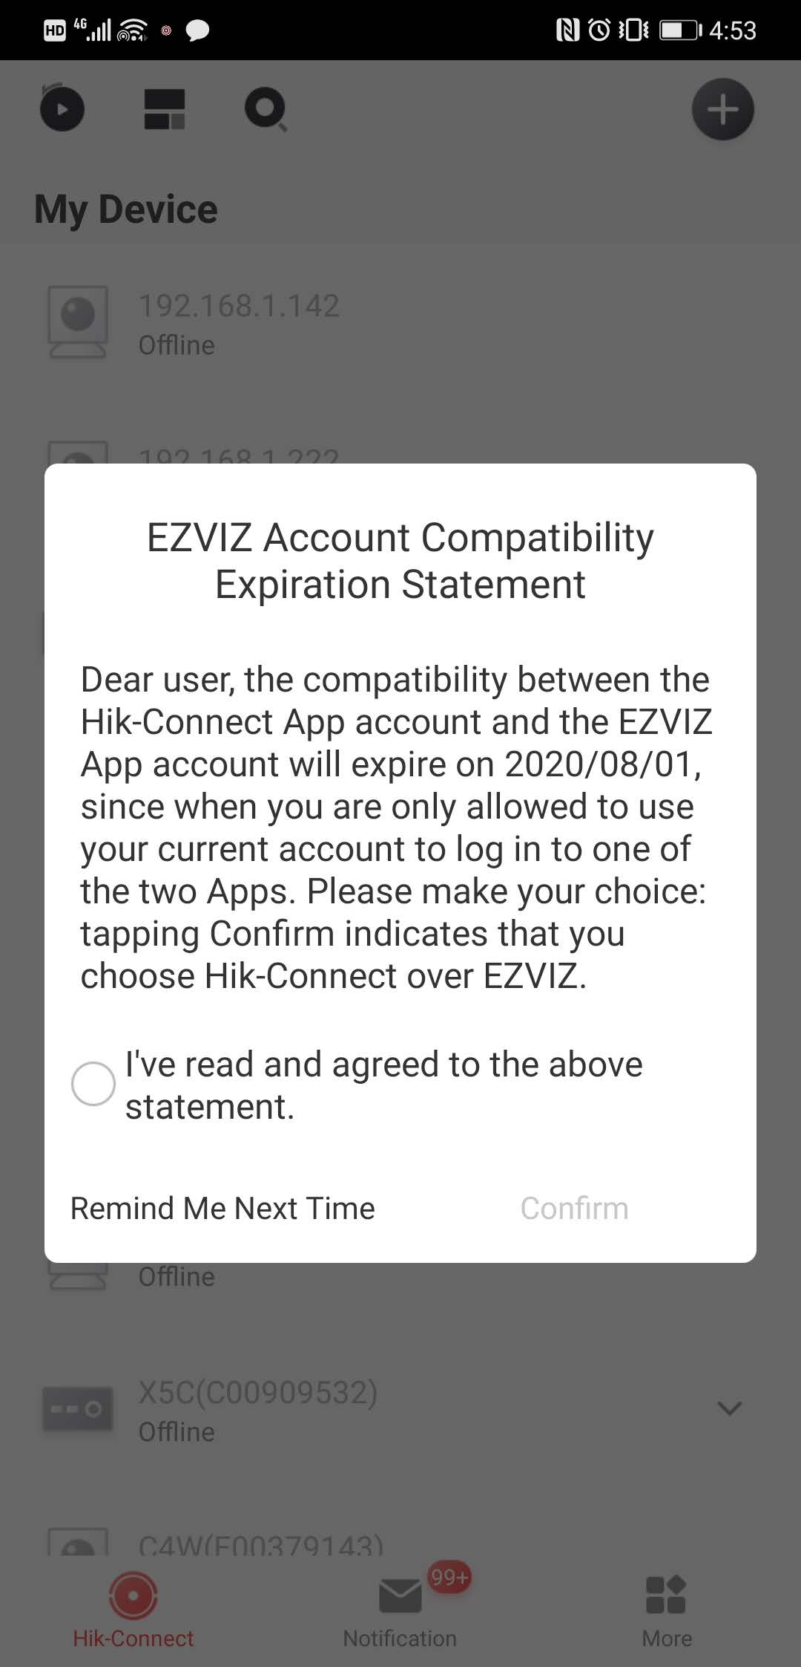
（3）Prompt the user that EZVIZ and Hik-Connect account will be isolated on August 1, 2020. If you click “Confirm”, the account can only log in to the current app after the isolation is completed;
（4）After reading the prompt, if the user decides to log in with the Hik-Connect account later, they can check “Confirm”. The next time when user logs in, the prompt will not pop up again. After the isolation takes effect, the account can only log in with the Hik-Connect app;
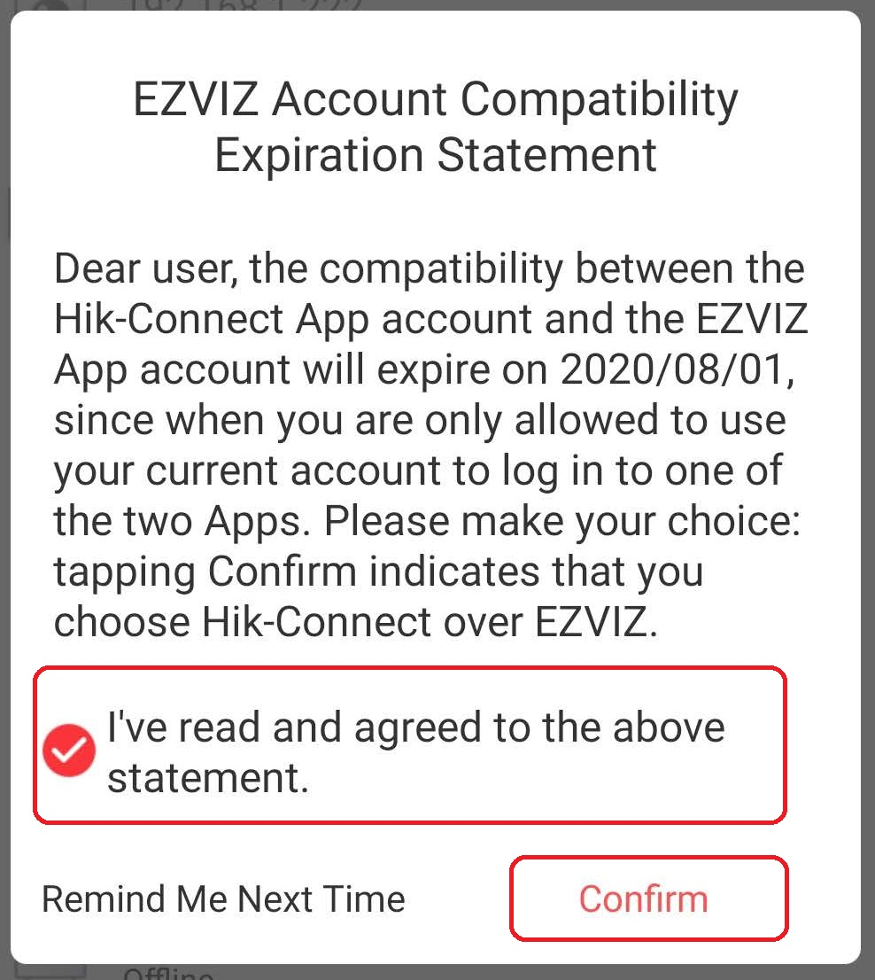
（5）If it is not decided whether to use Hik-Connect as the only app in the future at present, user can click "Remind Me Next Time" to skip this page, and the next time when user log in, the page will continue to pop up until the user makes a choice.
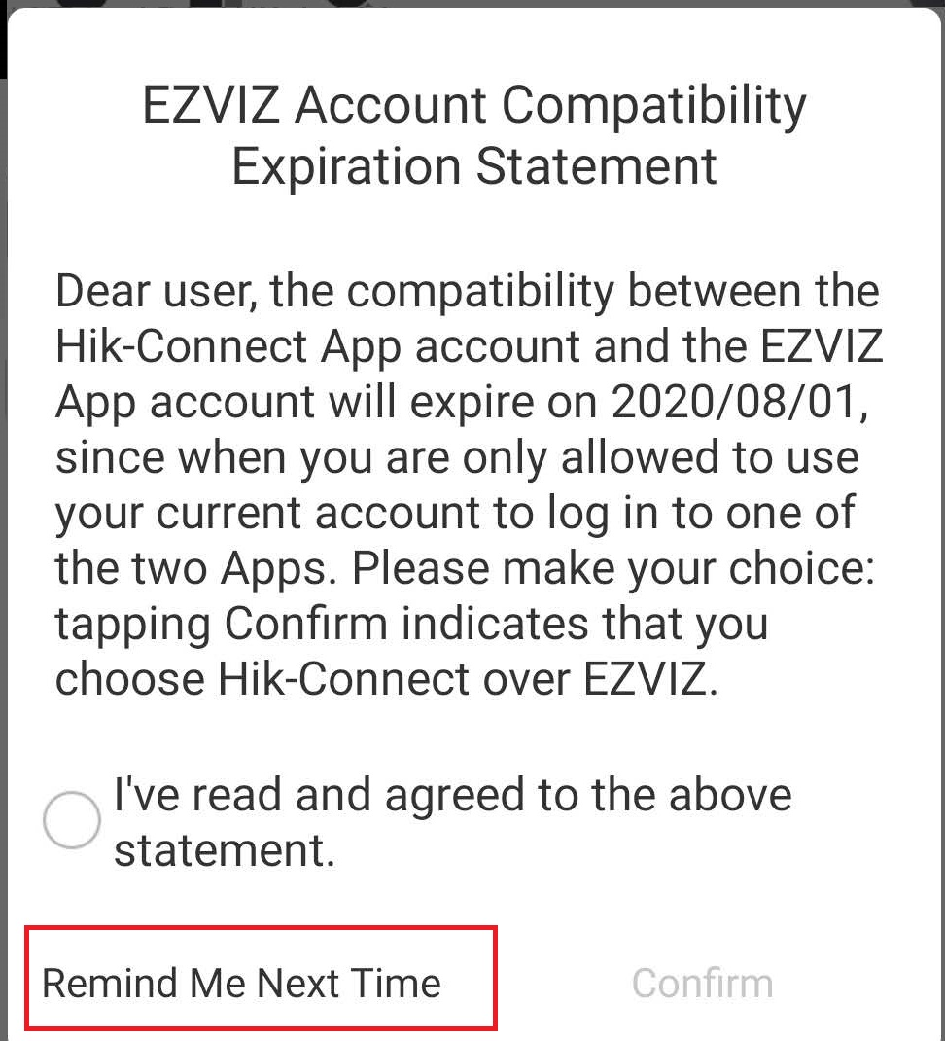

3. Others
1、For users who have not logged in during the buffer time, the server processes the account according to the current situation by default. After the isolation takes effect, only the corresponding app can be used to log in the account.
2、After the isolation takes effect, the accounts of EZVIZ and Hik-Connect will not be able to log in to each othe.
3、The newly registered account during the buffer time is isolated by default and cannot be used across apps.

4. After-sales issues
After the isolation takes effect, cross login is not allowed, so for accounts not migrated in time, login failure may occur. For such after-sales problems:
（1）First, check the customer number of the account, and make sure whether the login fails due to the inconsistency of the customer number;
（2）If the problem is caused by the inconsistency of customer number, inform the customer the reason, and ask the them to continue using the original client to login account;
（3）If the customer insists on using the current client, they shall be informed that they need to register an account under the current client, then log in the original client, unbind device with the old account, and then add the device to the new account.
（4）Additional note: after the isolation takes effect, we cannot modify the customer number for customer on the server.

